Regulations and standards | National Code Standard 9  Imagine Education Australia
Policy | For Imagine Education to assess a Student request for Deferral, Suspension of Studies (including granting a leave of absence) during the course or Cancellation of their enrolment through formal agreement in certain limited circumstances (based on the Compassionate or Compelling circumstances provided).  To “defer” an enrolment means to postpone the start date of that enrolment.  Only the student can initiate a deferral of their course start date.  To “suspend” an enrolment means to temporarily put the student’s studies on hold, (adjourn, delay, postpone) after the student has commenced studying in the course in which the student is currently enrolled.  The College notifies the Secretary of DHA via PRISMS as required under section 19 of the ESOS Act, of the deferment or suspension of enrolment.  Suspension or cancellation of enrolment could be initiated by either the student or the College.  The following may occur:  - A student may request to defer the commencement of studies, or temporarily suspension their studies on the grounds of compassionate or compelling circumstances.  - The College may inform the student of its intention to temporary suspend their studies due to the student’s misbehaviour. (Misbehaviour can also be grounds for cancellation of studies if the College’s internal policies specify this course of action.)  - A student may request to defer the commencement of his or her studies as a result of the inability of a student to commence his or her studies due to a delay in receiving a student visa: also, as a result of a delay in obtaining some pre-requisite for the commencement of studies.  In all the above cases, if the student has not commenced studies, a deferment will be processed, and if the student has commenced studies the enrolment will be temporarily suspended.  The College notifies the Secretary of DHA via PRISMS as required under section 19 of the ESOS Act, of the deferment or suspension of enrolment so that both DHA and DHA are aware of the student’s new enrolment status.  There are three possible outcomes of a suspension or deferment of the student’s Confirmation of Enrolment (CoE):  Viz:  - The College notifies the Secretary of DHA via PRISMS as required under section 19 of the ESOS Act, that it has suspended or deferred a student’s enrolment without affecting the end date of the CoE. In this case there is no change to the CoE or the student’s enrolment status. However, the notice of suspension or deferment will be recorded in PRISMS and an advice sent to DHA.  - The College notifies the Secretary of DHA via PRISMS as required under section 19 of the ESOS Act, that it has deferred or suspended a student’s enrolment and notifies DHA through PRISMS that the end date of the CoE will be affected by the suspension. In this case, PRISMS will cancel the CoE and offer the provider the opportunity to create a new CoE with a new end date. The College doesn’t have to create the new CoE immediately but can wait till the student has notified the College of his/her intended date of return.  - The College notifies the Secretary of DHA via PRISMS as required under section 19 of the ESOS Act, that it wishes to permanently cancel (terminate) the student’s enrolment. Once this process is complete and any appeals made by the student have run their course, the student’s CoE status will be listed as “cancelled.”  Note: Regardless of whether the suspension of enrolment is the result of a student request for suspension or initiated by the College, the period of suspension of enrolment (as entered in PRISMS), should not be included in attendance monitoring calculations.  Assessment of the Grounds for Deferment, Temporary Suspension or cancellation:  The College can only approve a deferral, or temporary suspension of a student enrolment on the following grounds:  - Compassionate or compelling circumstances.  Compassionate or compelling circumstances are generally those beyond the control of the student, when they have an impact on the student’s course progress or wellbeing. These could include (but are not limited to):  - Serious illness or injury, where a medical certificate states that the student was unable to attend class.  - Death or illness of close family members such as parents or grandparents  - Major political upheaval or natural disaster in the international student’s home country requiring  - Emergency travel and this has impacted, or will impact, on the student’s studies;  - A traumatic experience which could include:  - Involvement in, or witnessing of a serious accident; or  - Witnessing or being the victim of a serious crime, and this has impacted on the student;  - Where Imagine Education Australia was unable to offer a pre-requisite unit;  - Interviews with the Immigration Department, or Higher Education etc. institution for the purposes of further study would also qualify as compelling reasons for absence.  - Inability to begin studying on the course commencement date due to delay in receiving a student visa.  International students may also defer or suspend their studies with Imagine Education Australia for other reasons; however, the student will be required to provide compelling documentary evidence to support their request. Other reasons for deferment or suspension for compassionate and compelling circumstances may include:  - Requirement to attend a cultural event including weddings and christenings in the student’s home country  - Requirement to arrange care for children in their home country which requires the student to return to their home country.  - Unexpected hardship in relation to family member.  - Visiting family members overseas whom they have not seen for a considerable time.  Again, in the above cases, extenuating circumstances will need to be supported by appropriate evidence of some kind.  - Misbehaviour by the student.  Misbehaviour could include, (but is not limited to):  - Deliberately disruptive/rude to a point where the behaviour seriously interrupts the class  - Deliberately disobeying a lawful directive by a teacher or staff member.  - Assaulting another student, or making serious threats against another student  - Stealing from the school or another student  - Deliberately damaging school equipment  - Being found guilty of a serious criminal offence in Australia  - Deliberately falsifying any documents issued by the College (e.g. Attendance Certificate, or Class roll.)  - The students’ failure to pay an amount they were required to pay as stated in the written agreement  - A breach of the course progress or attendance requirements by the overseas student  Suspension or cancellation of enrolment for a student under 18 years of age.  Where Imagine Education Australia suspends or cancels the enrolment of a younger overseas student, Imagine Education Australia will continue to approve the welfare arrangements of the student until any of the following applies:  - The student has alternative welfare arrangements approved by another registered provider  - Care of the student by a parent or nominated relative is approved by immigration  - The student leaves Australia  - Immigration has been notified that the student will be cared for by a parent or nominated relative and a CAAW is no longer required OR that Imagine Education Australia has taken all steps to contact the student and is unable to do so, and the police and relevant government authorities have been alerted that we are unable to contact the student.  Visa holders must have their resumed study date entered into PRISMS after they have undertaken a suspension / ELICOS holiday.
Procedure | Simplified Procedure:  - Student applies for a Deferral, Suspension or Cancellation/Withdrawal by completing the Defer/Suspension/Withdrawal form and gives it to Student Services. Form must be completed in full with copy of supporting evidence e.g. flight tickets/Visa Cancellation. Forms located on the website.  - Request form received by Student Services Officer (SSO) and checked for appropriate documentation and recorded in SMS.  - Student is advised they must continue to attend class until they are advised of the outcome by email or arrangements are made for discussion/counselling.  - Request approved/refused by the General Manager or delegated Manager.  - Declined requests – Student is advised of this outcome via email by General Manager or delegated Manager.  - Approved request returned to Admissions for PRISMS and SMS action/SPO for finance action as above. (Check that all future courses are actioned). If Approved: Admissions emails student/agent/trainer/SPO/CANVAS.  Cancellation:  - Application is given to Admissions for withdrawal/cancellation of all courses.  - Application is given to Admissions for cancelling CoE's and reporting in PRISMS.  - Application is given to SPO for editing of fees.  Deferral:  - Application is given to Admissions for editing the Course start date/s.  - Application is given to the Admissions for SCV of CoE's in PRISMS.  Suspension:  - Application is given to Admissions for entering Suspension period and extending end date if requested.  - Application is retained by Admissions till date of commencement of suspension when PRISMS can be updated.  Detailed Procedure:  Deferment/Cancellation of a student’s enrolment.  Assessment of request  When a student requests a Deferral, Suspension or Cancellation of an enrolment, the reason for this request must be determined.  Documented on the Defer, Suspend or Cancellation/Withdrawal Form, the student should include the reason for the request and any other supporting information including the Compassionate or Compelling reasons.  Imagine Education Australia undertakes to consider each such request and to determine its merits, taking into consideration:  - The reasons outlined in the student’s Defer, Suspend or Cancellation/Withdrawal Form  - The best interests of the student  - The student’s academic performance and course progress  - Financial issues (whether or not the student has any fees or other outstanding liabilities such as debts to Imagine Education Australia) and personal financial circumstances. This includes future payments as outlined in the agreed payment plan  - The student’s attendance record  - The student’s disciplinary and conduct record  - The nature of the compassionate or compelling reasons provided by the student. (Imagine Education Australia reserves the right to deny the request for a reason simply because of financial or work-related reasons.)  - If an international student, whether or not he/she has breached student visa conditions related to attendance or course progress, and  - Any other matters considered relevant.  A Deferral, Suspension or Cancellation will not be granted by Imagine Education Australia where there are reasonable grounds for refusal. Reasonable grounds for refusal of a request may include, but not be limited to:  - Where the student visa holder has provided insufficient documentation to support reasons for the request;  - Where Imagine Education Australia deems that the Deferral, Suspension or Cancellation would be detrimental to the student’s welfare, future study, and/or career goals; this may include:  - Where the student has not utilised the full range of support services that are available to assist with academic and personal issues and /or where they have not made a genuine attempt to participate in the Imagine Education Australia courses to which they have been granted admission;  - Where it is believed the student is trying to avoid being reported to the Immigration Department for failure to meet the provider’s attendance, payment or academic progress requirements;  - Where the student has indicated they would prefer to study at another institution with lower fees and/or where the student claims financial difficulty but cannot provide evidence of the suddenness and/or unexpected nature of the difficulty;  - Where it is believed the student is deliberately trying to manipulate the Australian student visa system. For example, where a student accepted an offer to study at Imagine Education Australia, obtained a student visa through Imagine Education Australia’s participation in the Streamlined Visa Processing arrangements, but then seeks to transfer to a non-SVP provider without making a demonstrated effort to pursue their program of study at Imagine Education Australia;  - Where the student has outstanding fees owing to Imagine Education Australia;  - Where the student is not making academic progress as per the Course progress policy  - Procedures for Deferment or Cancellation of a Student’s Enrolment, at the Student’s Request:  The College will ask students who request a deferment or cancellation of their enrolment to complete a Deferral Application form, or Withdrawal Application form.  The SSO will assist the student to complete the letter of request if the student’s English is not good and the student will be asked to sign the application form.  The application will go to the General Manager or delegated Manager who will decide whether or not to approve the deferment based on the circumstances and any supporting evidence. In some cases, the College Principal will be asked to provide a final ruling.  The Admissions will also notify the student in writing of the College’s decision and advise the student that deferring/suspending/cancelling the enrolment may affect his or her student visa.  The email of the College’s written notification to the student will be saved in the student’s electronic file. The Student’s Student Management System (SMS) database record will also be noted. If the request comes as part of an email notification from overseas to the effect that the student has been refused a visa, or has not received a visa on time to commence the course, a copy of this email will be placed in the student’s electronic file and the student’s electronic records noted accordingly.  Note: Where the deferment/temporary suspension is at the student’s request, the College must notify the Secretary of DHA via PRISMS as required under section 19 of the ESOS Act, within 14 days of receiving the notification.  - Procedures for temporarily Suspending a Student’s Enrolment at the Student’s Request:  The College will ask students who request a temporary suspension of their enrolment to complete an Application to Temporarily Suspend Studies.  The SSO will assist the student to complete the letter of request if the student’s English is not good and the student will be asked to sign the application form.  The application will go to the General Manager or delegated Manager who will decide whether or not to approve the Suspension based on the circumstances and any supporting evidence. In some cases, the General Manager will be asked to provide a final ruling.  Note: students may use course allocated review weeks in the same way as course allocated holiday weeks if the General Manager or delegated Manager identifies that the student is up to date with all theory and practical assessments tasks one week prior to the proposed suspension commencement date.  If declined, the General Manager or delegated Manager advises the student of the outcome via email. SSO updates SMS declined status.  If approved, SSO takes form and payment of admin fee, diary notes in SMS, scans forms and saved to student folder, and forwards forms to Admissions for processing and cc’s CANVAS.  Admissions will notify the student in writing via email of the College’s decision and advise the student that deferring/suspending/cancelling the enrolment may affect his or her student visa, and to seek advice from immigration on the potential impact his or her student visa.  Admissions will CC. the student’s course Trainer and Student Payments to advise them of the approved Suspension so that the Trainer is aware relating to attendance and the SPO is aware relating to suspending Ezi-debit or a Payment Plan.  The email of the College’s written notification to the student will be placed in the student’s electronic file. The Student’s SMS database record will be also noted. If the request comes as part of an email notification from overseas to the effect that the student has left the country prior to the Suspension request, a copy of this email will also be placed in the student’s electronic file and the student’s electronic noted accordingly.  Admissions will then notify the Secretary of DHA via PRISMS as required under section 19 of the ESOS Act, that the student’s enrolment has been deferred, temporarily suspended or cancelled. Admissions will note this information in the student’s SMS database record.  Note: Where the deferment/temporary suspension is at the student’s request, the College must notify the Secretary of DHA via PRISMS as required under section 19 of the ESOS Act, within 14 days of receiving the notification.  The outcome of any fees refund, or refusal of refund that may result from the deferment will also be noted in the files, along with the results of any appeal that is subsequently made by the student and the written outcome of that appeal.  If the College refuses a student’s request to suspend his/her enrolment on compassionate or other grounds, the process will be similarly documented and recorded in detail on the student’s file. The student will also be notified in writing of his/her right to access the College’s dispute resolution and appeals process and a copy of this notification will be filed in the student’s paper file.  - Procedures for Temporarily Suspending/Cancelling a Student’s Enrolment for Misbehaviour, (instigated by the College), non-payment of fees or non-academic progression:  The decision whether or not to cancel or temporarily suspend a student’s COE is made only by the College Principal, in consultation with senior staff and after all evidence has been presented and discussed.  Where the College decides to proceed with the suspension or cancellation, it will inform the student in writing of its intention to report the student to DHA. At the same time, the College will inform the student in writing that he or she has 20 working days to access the College’s internal complaints and appeals process as per National Code Standard 10.2.1. To “access” means to initiate or start the appeals process: there is no expectation that the appeals process must be completed within 20 days.  National Code Standard 10.2.3 then requires that the hearing of the complaint or appeal must commence within 10 days of the date of formal lodgement of the complaint or appeal by the student.  The circumstances of the temporary suspension/cancellation will be noted in the student’s computer database record and a copy of the letter sent to the student will be placed on the student’s paper file.  If the student chooses to access the College’s internal appeals process, the College will maintain the student’s enrolment throughout this process. To “maintain the student’s enrolment” means that the College will not inform DHA of any change to the student’s enrolment status through PRISMS during this time. Exceptions to this could be special circumstances involving the welfare of another student or staff member (e.g. threats of physical or sexual assault by the offender.) In these cases, DHA should be notified of the circumstances immediately and they will take whatever action is deemed necessary.  Even though the College maintains the student’s enrolment status during the 20 days and any subsequent period of appeal, it does not require the College to continue to provide learning opportunities for the student in cases of serious misconduct.  If the student chooses to access an external appeals process as per the College’s dispute resolution policy, the College does not have to wait for the outcome of this process before notifying DHA of any change to the student’s enrolment status, through PRISMS.  Once the appeals process is complete, or is not taken up by the student and the temporary suspension/cancellation is confirmed, the College will immediately notify the Secretary of DHA via PRISMS as required under section 19 of the ESOS Act, if it wishes to temporarily suspend, or permanently cancel (terminate) the student’s enrolment, (as required under Section 19 of the ESOS Act) and the details will be noted on the student’s computer file and electronic file. The student will also be notified in writing of the action and the reasons for the action and a copy of the student letter placed on the files and the SMS system updated.  DHA’s Policy on Suspension and Cancellation:  If the College notifies DHA through PRISMS that a student’s enrolment has been suspended for a significant period, or is to be cancelled, the student must return to his/her home country unless special circumstances (e.g. serious injury), exist. While the College determines the enrolment status of the student, it is DHA who decides whether a student may remain in Australia or return home.  DHA’s policy is that if a student’s enrolment is suspended for a period of 28 days or longer, the student must return home unless special circumstances exist. Therefore, the College must refer any questions about whether a student must remain in Australia during a period of suspension to DHA.  Refund of Fees:  If appropriate, a refund of the balance of fees would then take place in accordance with the terms and timelines of the College’s Refund Policy. Where College property is damaged, or the College has been seriously inconvenienced, a proportion of fees may be retained by the College. Generally, it is not good policy to reward serious misbehaviour with a refund of fees, but where circumstances dictate it, some, or all of the student’s fees may be refunded.  Record Keeping Requirements for Deferments/Suspensions/Cancellations:  The College will keep accurate records of all deferments/suspensions/cancellations. Each step in the process will be documented by the Student Services/Administration/Enrolments and Student Payments Officer and held for at least two years in the student’s electronic file and as a notation in the files of the computerised Student Admin (SMS) Database.  Where the student is returning from suspension:  - Suspension of Studies form or ELICOS Holiday form is completed by student.  - Student attaches supporting compassionate or compelling evidence to their form (VET suspension of studies form only).  - Campus SSO or General Manager (GM) to leave diary note re: Suspension and whether it has been approved or not. Completed forms with the final decision are saved into the students J drive folder as Std ID-Suspension Approved/Not Approved (e.g. 123456-Suspension Approved).  If not approved Campus SSO or GM to communicate with student and save a copy of correspondence into Students folder on J drive.  If approved Suspension Form/ELICOS Holiday Form with supporting evidence to be emailed to Admissions for processing.  - Enrolment Officer (EO) or International Enrolments Supervisor (IES) will shorten the student’s current enrolment to the last day of study (always a Friday) prior to the suspension/holiday commencing and then create a new Offer (type: Variance) for the balance of the course commencing from the date of resumption approved on the form.  - EO/IES to notify SPO suspension has been processed.  - SPO add the balance of the students Payment Plan to the new Offer, accept the Offer, transfer fees paid in advanced and ITA future fees in the shortened course.  - SPO notifies EO/IES the suspension has been completed.  - On the actual start date or in that week, the SCV is processed in PRISMS to enter the suspension of studies.  - Students returning from suspension will now appear on the Starters Report for the week they are due to return. The Campus SSO should follow the normal process and email out Orientation information for the student so that we can confirm the student is returning as scheduled and that contact details are up-to-date.  - If the student replies and is not returning then the process of applying for a suspension should start again at Step 1.  - If the student replies and does return to studies as scheduled then the Campus SSO should mark them as arrived and add their Payment Attribute as per the Starters process.  If the student resumed study the General Manager or delegated Manager will either ‘commence CoE’ or ‘enter resumption date’ in PRISMS whichever is applicable.  If entering ‘resumption date’ the date will be the Monday of the week the student resumed study.  - If the student does not reply and does not complete Orientation the non-commencement policy is to be followed where the student will receive and an email from the General Manager or delegated Manager when on leave.  If the student has not responded by 9.00am on Friday then they are cancelled for non-commencement and reported for not resuming their studies after suspension.  It is the responsibility of the General Manager or delegated Manager at each location to follow up with the student if they make contact after being cancelled wanting to re-enrol.  NOTE 1: To enter Resumed Study date in PRISMS, when there is NO EXTENSION TO END DATE – (WHEN there is an extension to end date go to Note 2.) search student by entering student ID# in PRISMS:  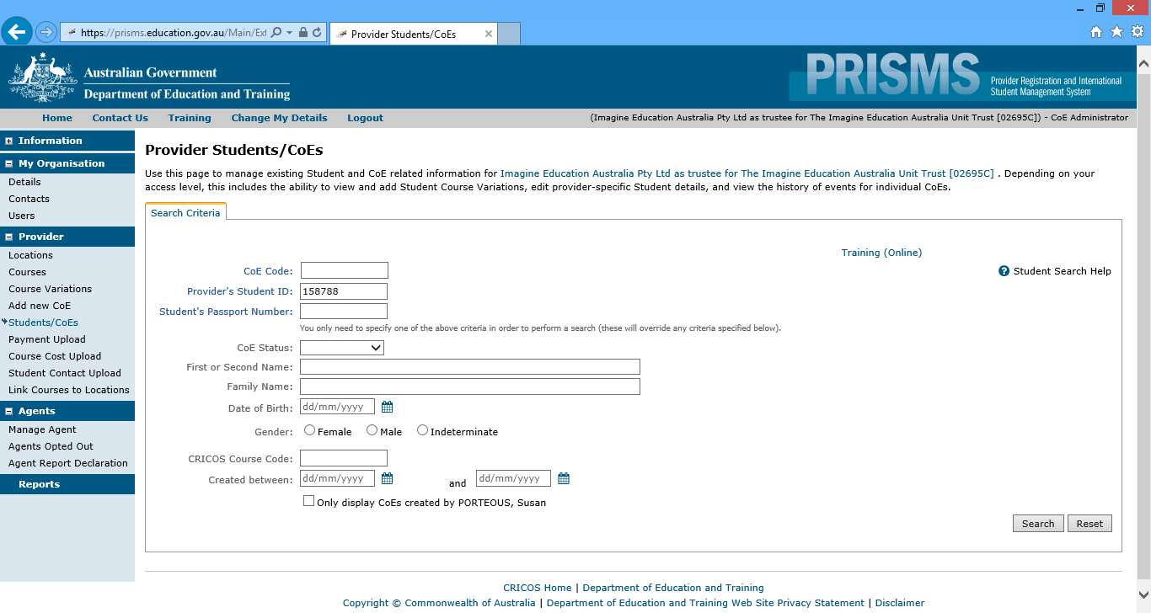  Click on Course Variation/Defaults tab:  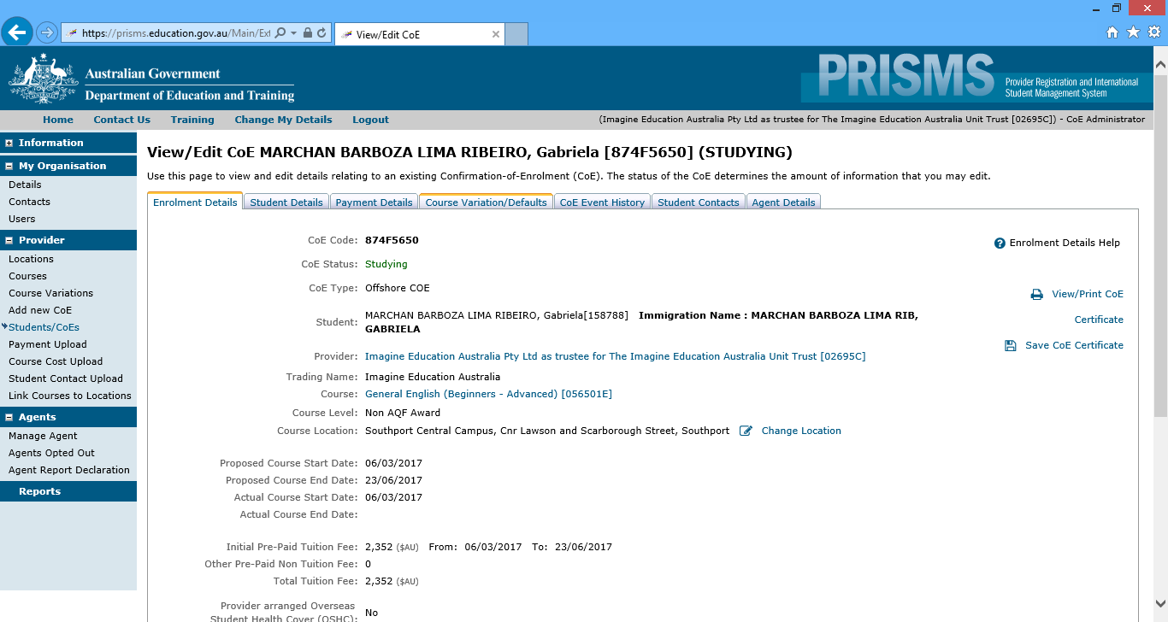  This will bring up the following screen view:  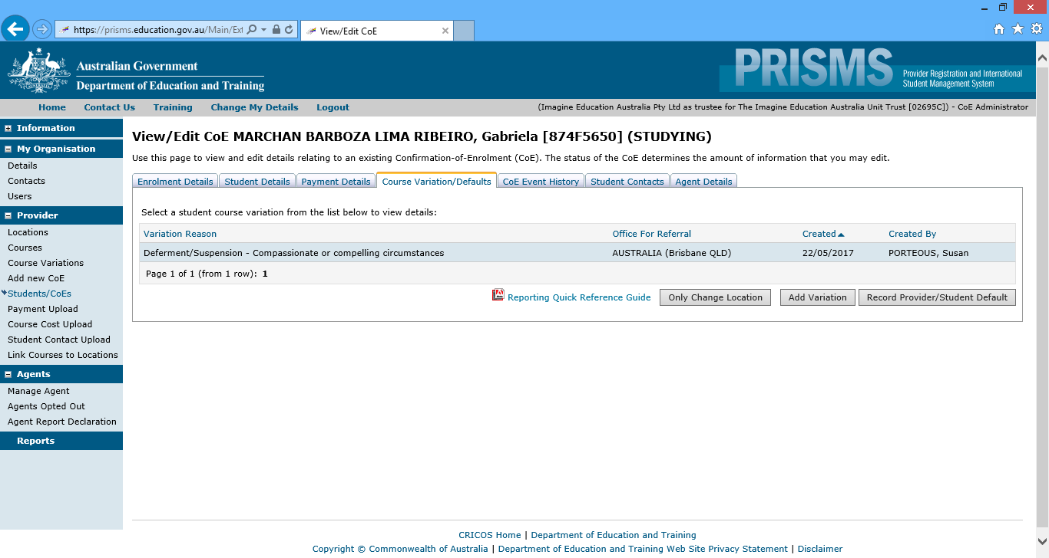  Click on the row - Deferment/Suspension-Compassionate or compelling circumstances. It will display the actual start and end date of the Suspension (although it refers to the suspension as Deferment):  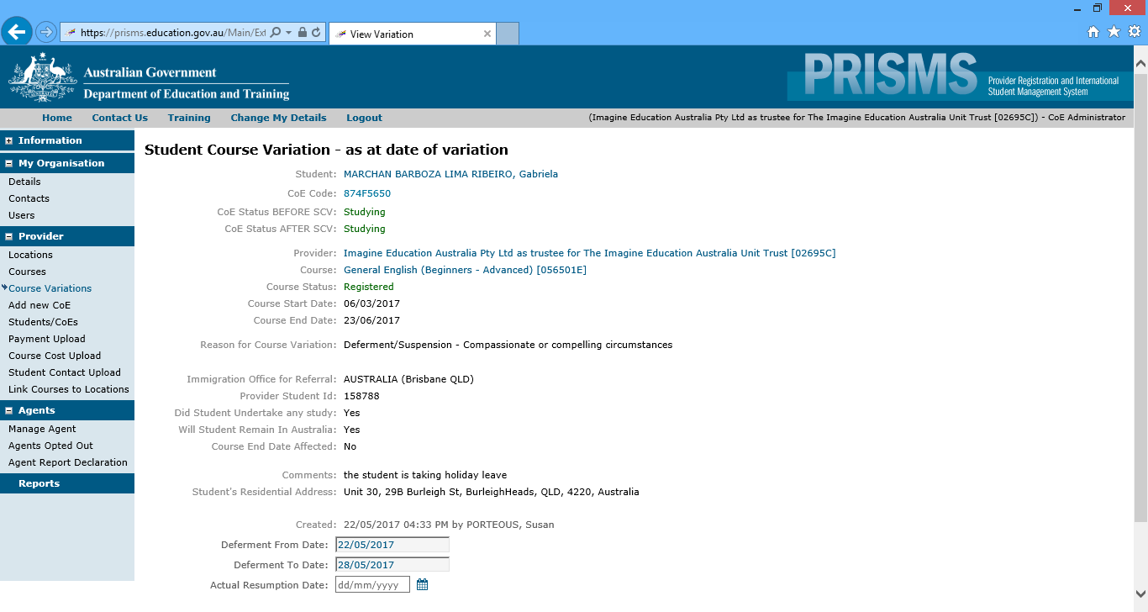  NOTE 2: In Prisms search for the student, then the course the student is to resume their studies in showing the new start date (This is the date the student is to resume studies after the suspension).  Click on the correct CoE, then go to “Confirm Study Commencement”:  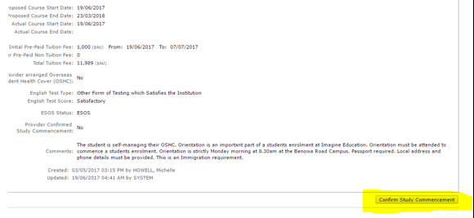  Then the following screen will appear. Then click on “Student Has commenced course”:  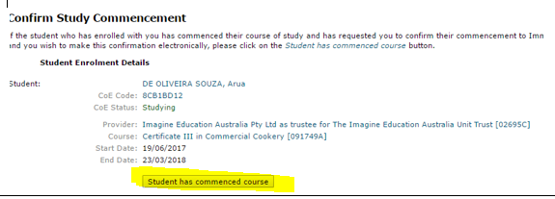

Supporting Documentation | - Change of Start or End Date form  - Temporary Suspension of Studies form  - Course Withdrawal form  - Compelling and Compassionate Policy and Procedure  - Course progress Policy and Procedure  - Intention to cancel for non-payment of fees Policy and Procedure  - PRISMS System – https://prisms.deewr.gov.au/Logon/Logon.aspx
Reviewed | February, 2025 | Date to be re-reviewed | June, 2026 | Version | 4.0
Amendments Made | Added amendment details to version control to mirror continuous improvement register.  Deferring, Suspending, Cancelling Student Enrolment Policy and Procedure flow chart amended to a ‘simplified procedure’ step-by-step and moved to beginning of procedure.  Resumption Date in PRISMS Policy and Procedure archived and combined to the bottom of Deferring, Suspending, Cancelling Student Enrolment Policy and Procedure.
Locations | - Imagine Education SharePoint Portal  - Imagine Education Website  - Imagine Education Student Handbook
File Location | "J:\Compliance\Policies and Procedures and Forms\Our Students\POLICIES AND PROCEDURES \Deferring Suspending Cancelling Student Enrolment Policy and Procedure v4.0.docx"

